|  |  |  |  |  |
| --- | --- | --- | --- | --- |
| 7 Best Running Shoes, 100+ Shoes Tested in 2022 | | | | |
|  |  |  | |  |
| Sporty Shoes  2022 | | |
| **simplilearn project for Backend Expert** | | Devnath.g22@gmail.com |

|  |  |
| --- | --- |
|  | **developer detail**  Application : **Sporty Shoes**  Developer Detail :  Name: Devnath Tandi  Designation : Java Developer  **Github link**  https://github.com/Dev25007/CoreJavaProjectPhase2/upload/main |

package org.sporty_shoes.model;

import java.io.Serializable;

import javax.persistence.Entity;

import javax.persistence.Id;

import javax.persistence.Table;

@Entity

@Table(name = "admin")

public class Admin implements Serializable {

    private static final long serialVersionUID = 1L;

    @Id

    private String email;

    private String password;

    public Admin() {

        super();

    }

    public Admin(String email, String password) {

        super();

        this.email = email;

        this.password = password;

    }

    public String getEmail() {

        return email;

    }

    public void setEmail(String email) {

        this.email = email;

    }

    public String getPassword() {

        return password;

    }

    public void setPassword(String password) {

        this.password = password;

    }

    @Override

    public String toString() {

        return String.format("Admin [email=%s, password=%s]", email, password);

    }

}

MyController.java

package org.sporty_shoes.controller;

import org.sporty_shoes.model.Admin;

import org.sporty_shoes.repository.AdminRepository;

import org.sporty_shoes.repository.ProductRepository;

import org.sporty_shoes.repository.PurchaseReportRepository;

import org.sporty_shoes.repository.Repository;

import org.sporty_shoes.repository.UserRepository;

import org.springframework.beans.factory.annotation.Autowired;

import org.springframework.stereotype.Controller;

import org.springframework.ui.ModelMap;

import org.springframework.web.bind.annotation.RequestMapping;

import org.springframework.web.bind.annotation.RequestMethod;

import org.springframework.web.bind.annotation.RequestParam;

@Controller

public class MyController {

    @Autowired

    AdminRepository adminRepository;

    @Autowired

    ProductRepository productRepository;

    @Autowired

    UserRepository  userRepository;

    @Autowired

    PurchaseReportRepository purchaseReportRepository;

    @Autowired

    Repository repository;

    @RequestMapping("/")

    public String showHome() {

        return "Home";

    }

    @RequestMapping(value="adminLogin",method =RequestMethod.GET)

    public String adminLoginPage() {

        return "AdminLogin";

    }

    @RequestMapping(value="forgotPassword",method =RequestMethod.GET)

    public String forgotPassword() {

        return "ForgotPassword";

    }

    @RequestMapping(value="adminForgotPassword",method =RequestMethod.POST)

    public String adminForgotPasswordPage(@RequestParam("email")String email,

            @RequestParam("password")String password,ModelMap map) {

        if(repository.forgotPassword(email,password))

            map.addAttribute("message","Password Updated");

        else

            map.addAttribute("message","Invalid Details");

        return "ForgotPassword";

    }

    @RequestMapping(value="adminPage",method=RequestMethod.POST)

    public String adminPage(@RequestParam(name="email")String email,

            @RequestParam(name="password")String password,ModelMap map) {

        if(adminRepository.verifyAdmin(new Admin(email,password)))

            return "AdminPage";

        else {

            map.addAttribute("message", "Invalid Details");

            return "AdminLogin";

        }

    }

    @RequestMapping(value="product",method=RequestMethod.GET)

    public String getAllProducts(ModelMap map) {

        map.addAttribute("productList",productRepository.getAllProducts());

        return "Product";

    }

    @RequestMapping(value="user",method=RequestMethod.GET)

    public String getAllUsers(ModelMap map) {

        map.addAttribute("userList",userRepository.getAllUsers());

        return "User";

    }

    @RequestMapping(value="searchUser",method=RequestMethod.GET)

    public String searchUser(@RequestParam("email")String email,ModelMap map) {

        map.addAttribute("userList",userRepository.searchUser(email));

        return "User";

    }

    @RequestMapping(value="purchaseReport",method=RequestMethod.GET)

    public String getRport(ModelMap map) {

        map.addAttribute("report",purchaseReportRepository.getReport());

        return "PurchaseReport";

    }

    @RequestMapping(value="deleteProduct",method=RequestMethod.GET)

    public String deleteProduct(@RequestParam("id")int id,ModelMap map) {

        if(productRepository.deleteProduct(id))

            map.addAttribute("message","Product Deleted Successfully");

        else

            map.addAttribute("message","Try after few minutes");

        map.addAttribute("productList",productRepository.getAllProducts());

        return "Product";

    }

}

Product.java

package org.sporty_shoes.model;

import java.io.Serializable;

import javax.persistence.Entity;

import javax.persistence.GeneratedValue;

import javax.persistence.GenerationType;

import javax.persistence.Id;

import javax.persistence.Table;

@Entity

@Table(name="product")

public class Product implements Serializable{

    private static final long serialVersionUID = 1L;

    @Id

    @GeneratedValue(strategy=GenerationType.AUTO)

    private int productId;

    private String productName;

    private int productPrice;

    private String productDiscription;

    public Product() {

        super();

    }

    public Product(String productName, int productPrice, String productDiscription) {

        super();

        this.productName = productName;

        this.productPrice = productPrice;

        this.productDiscription = productDiscription;

    }

    public int getProductId() {

        return productId;

    }

    public void setProductId(int productId) {

        this.productId = productId;

    }

    public String getProductName() {

        return productName;

    }

    public void setProductName(String productName) {

        this.productName = productName;

    }

    public int getProductPrice() {

        return productPrice;

    }

    public void setProductPrice(int productPrice) {

        this.productPrice = productPrice;

    }

    public String getProductDiscription() {

        return productDiscription;

    }

    public void setProductDiscription(String productDiscription) {

        this.productDiscription = productDiscription;

    }

    @Override

    public String toString() {

        return String.format("Product [productId=%s, productName=%s, productprice=%s, productDiscription=%s]",

                productId, productName, productPrice, productDiscription);

    }

}

PurchaseReport.java

package org.sporty_shoes.model;

import java.io.Serializable;

import javax.persistence.Entity;

import javax.persistence.GeneratedValue;

import javax.persistence.GenerationType;

import javax.persistence.Id;

import javax.persistence.Table;

@Entity

@Table(name="purchase_report")

public class PurchaseReport implements Serializable {

    private static final long serialVersionUID = 1L;

    @Id

    @GeneratedValue(strategy=GenerationType.AUTO)

    private int reportId;

    private String reportProductName;

    private String reportUserEmail;

    private String reportDate;

    private int reportPrice;

    public PurchaseReport() {

        super();

    }

    public PurchaseReport(String reportProductName, String reportUserEmail, String reportDate, int reportPrice) {

        super();

        this.reportProductName = reportProductName;

        this.reportUserEmail = reportUserEmail;

        this.reportDate = reportDate;

        this.reportPrice = reportPrice;

    }

    public int getReportId() {

        return reportId;

    }

    public void setReportId(int reportId) {

        this.reportId = reportId;

    }

    public String getReportProductName() {

        return reportProductName;

    }

    public void setReportProductName(String reportProductName) {

        this.reportProductName = reportProductName;

    }

    public String getReportUserEmail() {

        return reportUserEmail;

    }

    public void setReportUserEmail(String reportUserEmail) {

        this.reportUserEmail = reportUserEmail;

    }

    public String getReportDate() {

        return reportDate;

    }

    public void setReportDate(String reportDate) {

        this.reportDate = reportDate;

    }

    public int getReportPrice() {

        return reportPrice;

    }

    public void setReportPrice(int reportPrice) {

        this.reportPrice = reportPrice;

    }

    public static long getSerialversionuid() {

        return serialVersionUID;

    }

    @Override

    public String toString() {

        return String.format(

                "PurchaseReport [reportId=%s, reportProductName=%s, reportUserEmail=%s, reportDate=%s, reportPrice=%s]",

                reportId, reportProductName, reportUserEmail, reportDate, reportPrice);

    }

}

User.java

package org.sporty_shoes.model;

import java.io.Serializable;

import javax.persistence.Entity;

import javax.persistence.GeneratedValue;

import javax.persistence.GenerationType;

import javax.persistence.Id;

import javax.persistence.Table;

@Entity

@Table(name="user")

public class User implements Serializable {

    private static final long serialVersionUID = 1L;

    @Id

    @GeneratedValue(strategy=GenerationType.AUTO)

    private int userId;

    private String userName;

    private String userEmail;

    private int userAge;

    private String userGender;

    private String userAddress;

    public User() {

        super();

    }

    public User(String userName, String userEmail, int userAge, String userGender, String userAddress) {

        super();

        this.userName = userName;

        this.userEmail = userEmail;

        this.userAge = userAge;

        this.userGender = userGender;

        this.userAddress = userAddress;

    }

    public int getUserId() {

        return userId;

    }

    public void setUserId(int userId) {

        this.userId = userId;

    }

    public String getUserName() {

        return userName;

    }

    public void setUserName(String userName) {

        this.userName = userName;

    }

    public String getUserEmail() {

        return userEmail;

    }

    public void setUserEmail(String userEmail) {

        this.userEmail = userEmail;

    }

    public int getUserAge() {

        return userAge;

    }

    public void setUserAge(int userAge) {

        this.userAge = userAge;

    }

    public String getUserGender() {

        return userGender;

    }

    public void setUserGender(String userGender) {

        this.userGender = userGender;

    }

    public String getUserAddress() {

        return userAddress;

    }

    public void setUserAddress(String userAddress) {

        this.userAddress = userAddress;

    }

    public static long getSerialversionuid() {

        return serialVersionUID;

    }

    @Override

    public String toString() {

        return String.format("User [userId=%s, userName=%s, userEmail=%s, userAge=%s, userGender=%s, userAddress=%s]",

                userId, userName, userEmail, userAge, userGender, userAddress);

    }

}

AdminRepository.java

package org.sporty_shoes.repository;

import java.util.List;

import org.hibernate.Query;

import org.hibernate.Session;

import org.hibernate.Transaction;

import org.sporty_shoes.model.Admin;

import org.springframework.orm.hibernate5.HibernateTemplate;

@SuppressWarnings("deprecation")

public class AdminRepository {

    private HibernateTemplate hibernateTemplate;

    public HibernateTemplate getHibernateTemplate() {

        return hibernateTemplate;

    }

    public void setHibernateTemplate(HibernateTemplate hibernateTemplate) {

        this.hibernateTemplate = hibernateTemplate;

    }

    public boolean verifyAdmin(Admin a) {

        Session session=hibernateTemplate.getSessionFactory().openSession();

        Transaction transaction=session.beginTransaction();

        String hql = "from Admin where email=:email and password=:password";

        Query<Admin> query = session.createQuery(hql,Admin.class);

        query.setParameter("email", a.getEmail());

        query.setParameter("password", a.getPassword());

        List<Admin> results = query.getResultList();

        transaction.commit();

        session.close();

        return results.size()>0;

    }

}

ProductRepository.java

package org.sporty_shoes.repository;

import java.util.List;

import org.hibernate.Session;

import org.hibernate.Transaction;

import org.sporty_shoes.model.Product;

import org.springframework.orm.hibernate5.HibernateTemplate;

public class ProductRepository {

    HibernateTemplate hibernateTemplate;

    public ProductRepository() {

        super();

    }

    public ProductRepository(HibernateTemplate hibernateTemplate) {

        super();

        this.hibernateTemplate = hibernateTemplate;

    }

    public HibernateTemplate getHibernateTemplate() {

        return hibernateTemplate;

    }

    public void setHibernateTemplate(HibernateTemplate hibernateTemplate) {

        this.hibernateTemplate = hibernateTemplate;

    }

    public List<Product> getAllProducts(){

        List<Product> productList=hibernateTemplate.loadAll(Product.class);

        return productList;

    }

    public Boolean deleteProduct(int id) {

        try {

        Session session=hibernateTemplate.getSessionFactory().openSession();

        Transaction transaction=session.beginTransaction();

        Product p=session.get(Product.class, id);

        session.delete(p);

        transaction.commit();

        session.close();

        }

        catch(Exception e) {

            return false;

        }

        return true;

    }

}

PurchaseReportRepository.java

package org.sporty_shoes.repository;

import java.util.List;

import org.sporty_shoes.model.PurchaseReport;

import org.springframework.orm.hibernate5.HibernateTemplate;

public class PurchaseReportRepository {

    HibernateTemplate hibernateTemplate;

    public HibernateTemplate getHibernateTemplate() {

        return hibernateTemplate;

    }

    public void setHibernateTemplate(HibernateTemplate hibernateTemplate) {

        this.hibernateTemplate = hibernateTemplate;

    }

    @SuppressWarnings("deprecation")

    public List<PurchaseReport> getReport(){

        @SuppressWarnings("unchecked")

        List<PurchaseReport> report=(List<PurchaseReport>) hibernateTemplate.find("from PurchaseReport order by reportProductName,reportDate");

        return report;

    }

}

Repository.java

package org.sporty_shoes.repository;

import org.hibernate.Query;

import org.hibernate.Session;

import org.hibernate.Transaction;

import org.sporty_shoes.model.Admin;

import org.springframework.orm.hibernate5.HibernateTemplate;

@SuppressWarnings("deprecation")

public class Repository {

    private HibernateTemplate hibernateTemplate;

    public HibernateTemplate getHibernateTemplate() {

        return hibernateTemplate;

    }

    public void setHibernateTemplate(HibernateTemplate hibernateTemplate) {

        this.hibernateTemplate = hibernateTemplate;

    }

    public boolean forgotPassword(String email,String password) {

        Session session=hibernateTemplate.getSessionFactory().openSession();

        Transaction tx=session.beginTransaction();

        @SuppressWarnings("unchecked")

        Query<Admin> q=session.createQuery("update Admin set password=:p where email=:e");

        q.setParameter("e",email);

        q.setParameter("p",password);

        int status=q.executeUpdate();

        System.out.println(status);

        tx.commit();

        return status>0?true:false;

    }

}

UserRepository.java

package org.sporty_shoes.repository;

import java.util.List;

import org.hibernate.Query;

import org.hibernate.Session;

import org.hibernate.Transaction;

import org.sporty_shoes.model.User;

import org.springframework.orm.hibernate5.HibernateTemplate;

@SuppressWarnings("deprecation")

public class UserRepository {

    HibernateTemplate hibernateTemplate;

    public UserRepository() {

        super();

    }

    public UserRepository(HibernateTemplate hibernateTemplate) {

        super();

        this.hibernateTemplate = hibernateTemplate;

    }

    public HibernateTemplate getHibernateTemplate() {

        return hibernateTemplate;

    }

    public void setHibernateTemplate(HibernateTemplate hibernateTemplate) {

        this.hibernateTemplate = hibernateTemplate;

    }

    public List<User> getAllUsers(){

        List<User> userList=hibernateTemplate.loadAll(User.class);

        return userList;

    }

    public List<User> searchUser(String email){

        Session session=hibernateTemplate.getSessionFactory().openSession();

        Transaction transaction=session.beginTransaction();

        String hql = "from User where userEmail=:email";

        Query<User> query = session.createQuery(hql,User.class);

        query.setParameter("email", email);

        List<User> user = query.getResultList();

        transaction.commit();

        session.close();

        return user;

    }

}

**Web files and outputs**

Home.jsp

<%@ page language="java" contentType="text/html; charset=ISO-8859-1"

    pageEncoding="ISO-8859-1"%>

<!DOCTYPE html>

<html>

<head>

<meta charset="ISO-8859-1">

<title>Sporty Shoes</title>

</head>

<body style="background-color:rgb(255,252,211)">

<h1 align="center">Sporty Shoes</h1><br><br>

<p align="center"><a href="adminLogin" style="font-size:25px;">Admin Login</a></p>

</body>

</html>

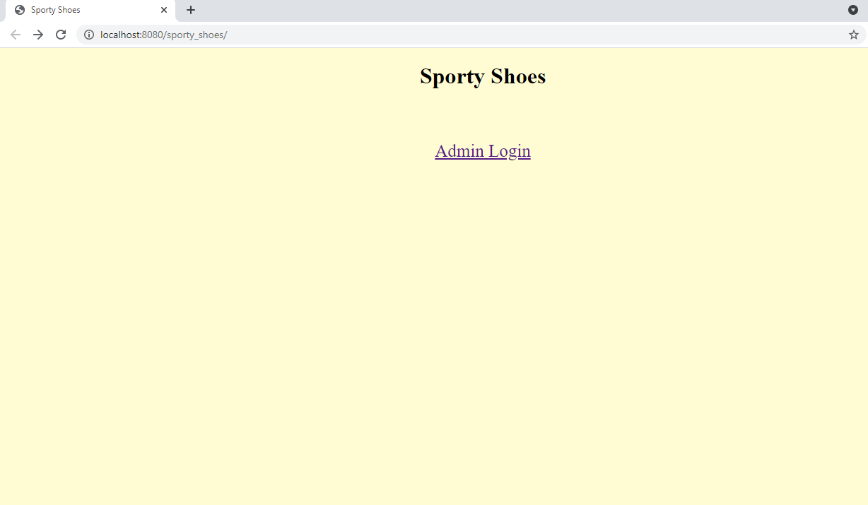

This is the Home page of the application Where we have one button links Admin Login

When we click on Admin Login Button the another page opens like below

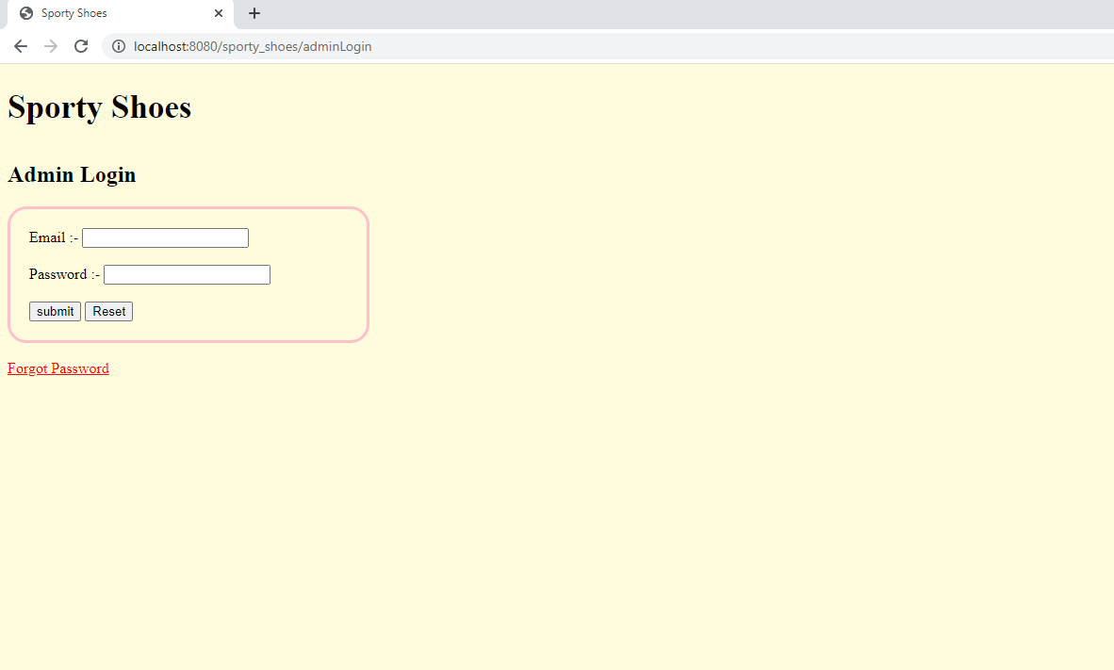

In this page we can login by valid credentials and you’ll get the page looks like below :

AdminLogin.jsp

<%@ page language="java" contentType="text/html; charset=ISO-8859-1"

    pageEncoding="ISO-8859-1"%>

<!DOCTYPE html>

<html>

<head>

<meta charset="ISO-8859-1">

<title>Sporty Shoes</title>

</head>

<body style="background-color:rgb(255,252,222)">

<br>

<a href=Home.jsp style="color:black;text-decoration:none ;font-size:35px;font-weight:bold;">Sporty Shoes</a>

<br><br>

<h2>Admin Login</h2>

<div style="border:3px solid pink;width:25%;border-radius:20px;padding:20px">

<form action=adminPage method=post>

    <label for=email>Email :-</label> <input type="email" name=email id=email /><br><br>

    <label for=pass>Password :-</label> <input type="password" name=password id=pass /><br><br>

    <input type=submit value=submit /> <input type=reset />

</form>

</div><br>

<a href=forgotPassword style="font-size:25;color:red;">Forgot Password</a>

<p style="color:green;">${message}</p>

</body>

</html>

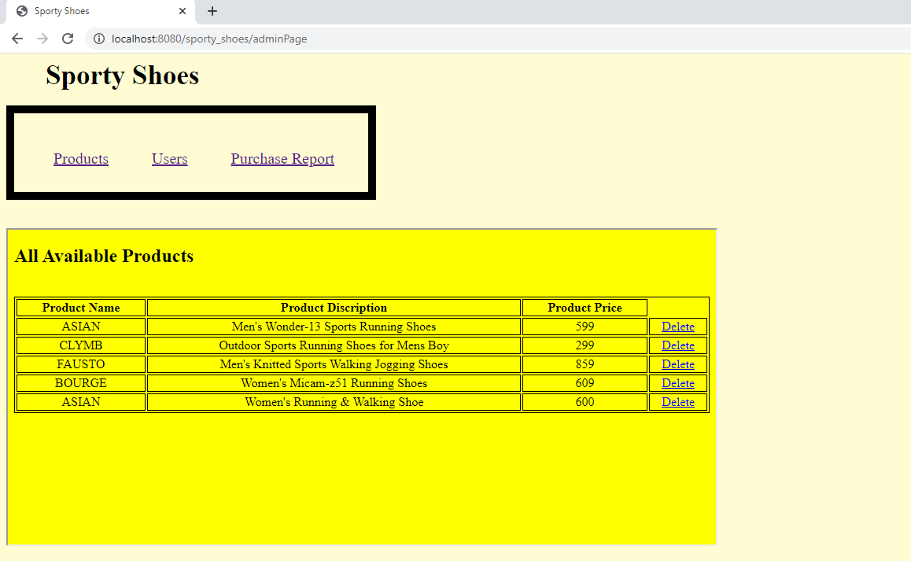

Here we have 3 Button links Products Users and Purchase Report we can use any of these as per the Admin needs

AdminPage.jsp

<%@ page language="java" contentType="text/html; charset=ISO-8859-1"

    pageEncoding="ISO-8859-1"%>

<!DOCTYPE html>

<html>

<head>

<meta charset="ISO-8859-1">

<title>Sporty Shoes</title>

<style>

div {

    border:10px solid black;

    color:blue;

    font-size:20px;

    height:100px;

    width:450px;

}

a{

    padding-left:50px;

}

</style>

</head>

<body style="background-color:rgb(255,252,211)">

<a href=Home.jsp style="color:black;text-decoration:none ;font-size:35px;font-weight:bold;">Sporty Shoes</a>

<br><br>

<div>

<br><br>

<a href="product" target="iframe">Products</a>

<a href="user" target="iframe">Users</a>

<a href="purchaseReport" target="iframe">Purchase Report</a>

</div><br><br>

<iframe src="product" name="iframe" style="height:400px;width:900px;"></iframe>

</body>

</html>

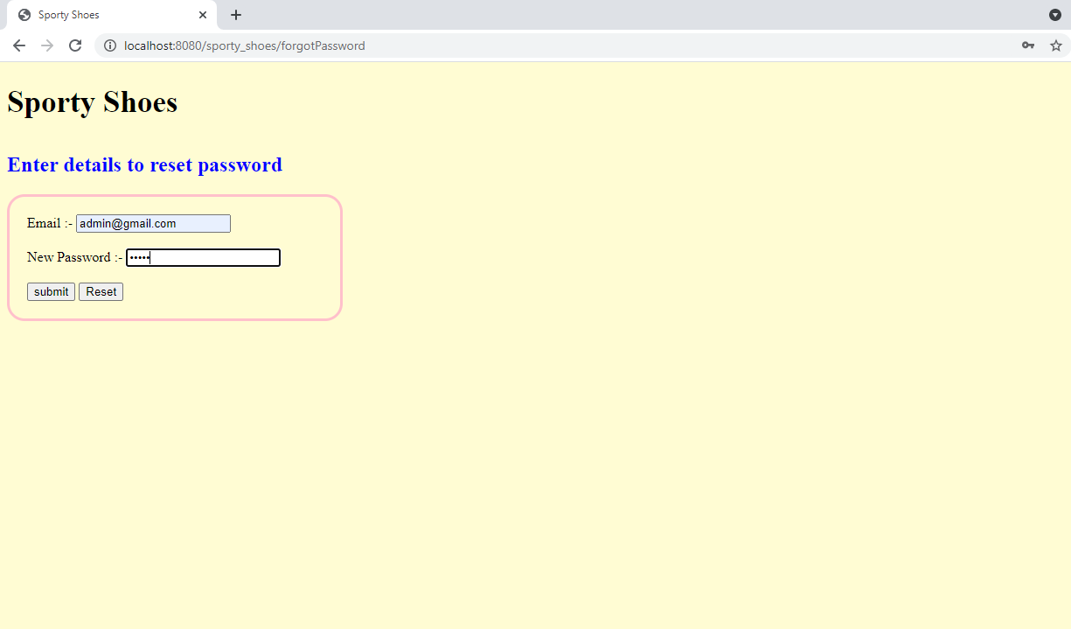

When we forgot the password then we have the option to reset the password

ForgotPassword.jsp

<%@ page language="java" contentType="text/html; charset=ISO-8859-1"

    pageEncoding="ISO-8859-1"%>

<!DOCTYPE html>

<html>

<head>

<meta charset="ISO-8859-1">

<title>Sporty Shoes</title>

</head>

<body style="background-color:rgb(255,252,211)">

<br>

<a href=Home.jsp style="color:black;text-decoration:none ;font-size:35px;font-weight:bold;">Sporty Shoes</a>

<br><br>

<h2 style="color:blue;">Enter details to reset password</h2>

<div style="border:3px solid pink;width:25%;border-radius:20px;padding:20px">

<form action=adminForgotPassword method=post>

    <label for=email>Email :-</label> <input type="email" name=email id=email /><br><br>

    <label for=pass>New Password :-</label> <input type="password" name=password id=pass /><br><br>

    <input type=submit value=submit /> <input type=reset />

</form>

</div><br><br>

<p style="color:green;">${message}</p>

</body>

</html>



Product.jsp

<%@ page language="java" contentType="text/html; charset=ISO-8859-1"

    pageEncoding="ISO-8859-1"%>

<%@ taglib uri="http://java.sun.com/jsp/jstl/core" prefix="c" %>

<!DOCTYPE html>

<html>

<head>

<meta charset="ISO-8859-1">

<title>Sporty Shoes</title>

<style>

table,th,td {

    border:1px solid black;

    text-align:center;

}

</style>

</head>

<body style="background-color:yellow;">

<h2>All Available Products</h2>

<br>

<table style="width:100%">

    <tr>

        <th>Product Name</th>

        <th>Product Discription</th>

        <th>Product Price</th>

    </tr>

    <c:forEach var="product" items="${productList}">

        <tr>

            <td> ${product.productName} </td>

            <td> ${product.productDiscription} </td>

            <td> ${product.productPrice} </td>

            <td><a href="deleteProduct?id=${product.productId}">Delete</a></td>

        </tr>

    </c:forEach>

</table>

<br><br>

<p style="color:green;">${message}</p>

</body>

</html>

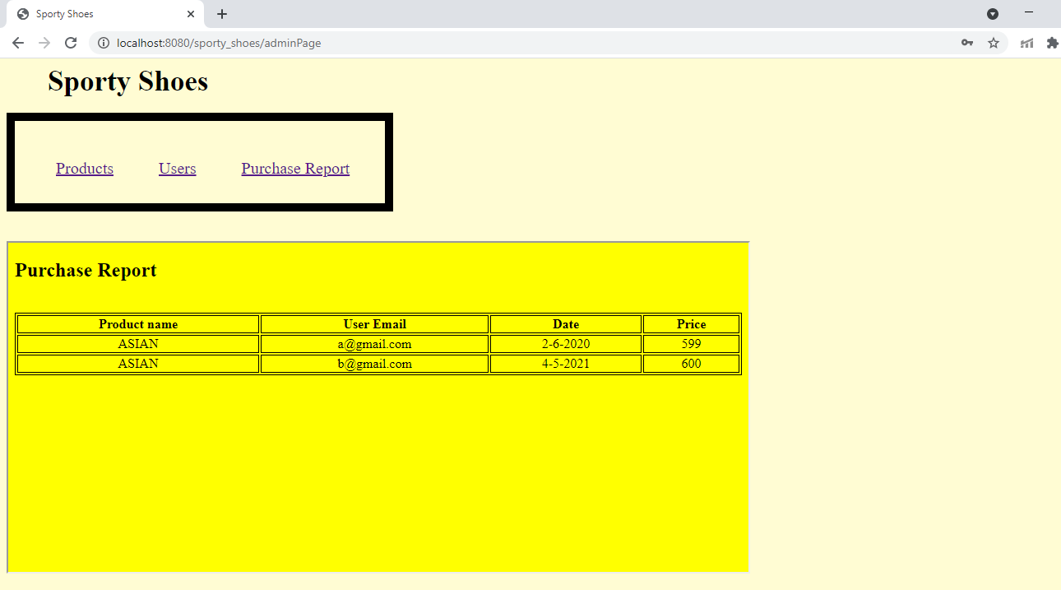

PurchaseReport.jsp

<%@ page language="java" contentType="text/html; charset=ISO-8859-1"

    pageEncoding="ISO-8859-1"%>

<%@ taglib uri="http://java.sun.com/jsp/jstl/core" prefix="c" %>

<!DOCTYPE html>

<html>

<head>

<meta charset="ISO-8859-1">

<title>Sporty Shoes</title>

<style>

table,th,td {

    border:1px solid black;

    text-align:center;

}

</style>

</head>

<body style="background-color:yellow;">

<h2>Purchase Report</h2>

<br>

<table style="width:100%">

    <tr>

        <th>Product name</th>

        <th>User Email</th>

        <th>Date</th>

        <th>Price</th>

    </tr>

    <c:forEach var="report" items="${report}">

        <tr>

            <td> ${report.reportProductName} </td>

            <td> ${report.reportUserEmail} </td>

            <td> ${report.reportDate} </td>

            <td> ${report.reportPrice} </td>

        </tr>

    </c:forEach>

</table>

</body>

</html>

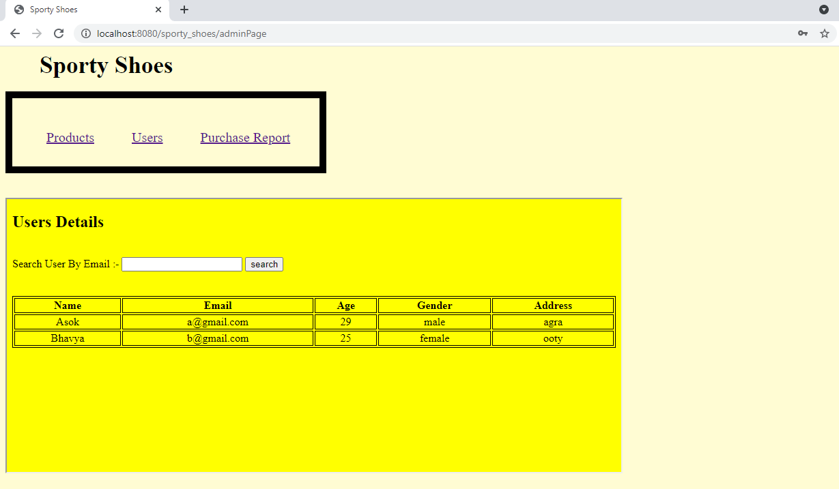

User.jsp

<%@ page language="java" contentType="text/html; charset=ISO-8859-1"

    pageEncoding="ISO-8859-1"%>

<%@ taglib uri="http://java.sun.com/jsp/jstl/core" prefix="c" %>

<!DOCTYPE html>

<html>

<head>

<meta charset="ISO-8859-1">

<title>Sporty Shoes</title>

<style>

table,th,td {

    border:1px solid black;

    text-align:center;

}

</style>

</head>

<body style="background-color:yellow;">

<h2>Users Details</h2>

<br>

<form action=searchUser>

    <label for="search">Search User By Email :-</label>  <input type="email" name="email" id="search"/>

    <input type="submit" value="search"/>

</form><br><br>

<table style="width:100%">

    <tr>

        <th>Name</th>

        <th>Email</th>

        <th>Age</th>

        <th>Gender</th>

        <th>Address</th>

    </tr>

    <c:forEach var="user" items="${userList}">

        <tr>

            <td> ${user.userName} </td>

            <td> ${user.userEmail} </td>

            <td> ${user.userAge} </td>

            <td> ${user.userGender} </td>

            <td> ${user.userAddress} </td>

        </tr>

    </c:forEach>

</table>

</body>

</html>

